A “337” is any major repair or alteration to an aircraft. When we add new aircraft to our fleet, we must list all 337’s, and add them to the aircraft’s “Conformance” binder.
If tasked with the job of “listing 337’s”, the following is a basic overview.
We order a DVD from the FAA which contains every 337 for the life of the aircraft. You will print them off (it is not uncommon to print close to a ream of paper). After printing, sort them by date, earliest to latest. Keep in mind that supporting paperwork is kept with the 337’s throughout the paperwork and they should stay together.
To open the form you will be using, go to: “L:\Maintenane\Forms\List of FAA Form 337”. Once open, “Save As” M:\Records\Mayo-AC\N#XXXX\List of FAA Form 337. You cannot add pages to this PDF, so it may be necessary to use more than one page. If this is the case, name them in order using A-Z, for example: A)List of FAA Form 337 (Date Range), B)List of FAA Form 337 (Date Range), etc.
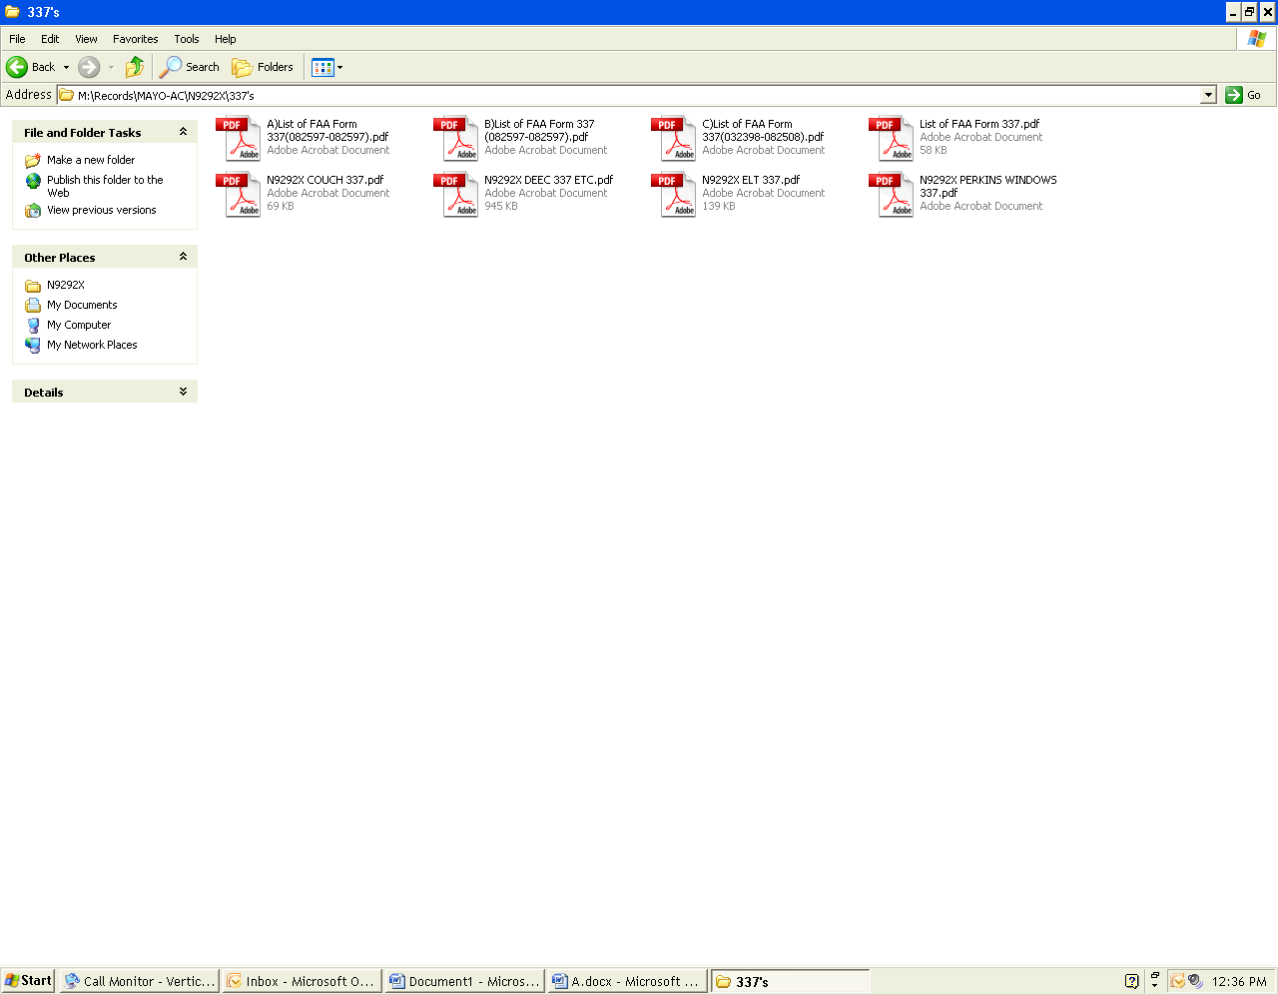
This form is a PDF with fields that you can fill in; however, there is only a small bit of space for descriptions, so it is essential to keep it short but specific. If you have to, it is okay to use more than one line, as long as it is clear that the description is all one 337.
Example of how to name multiple 337’s
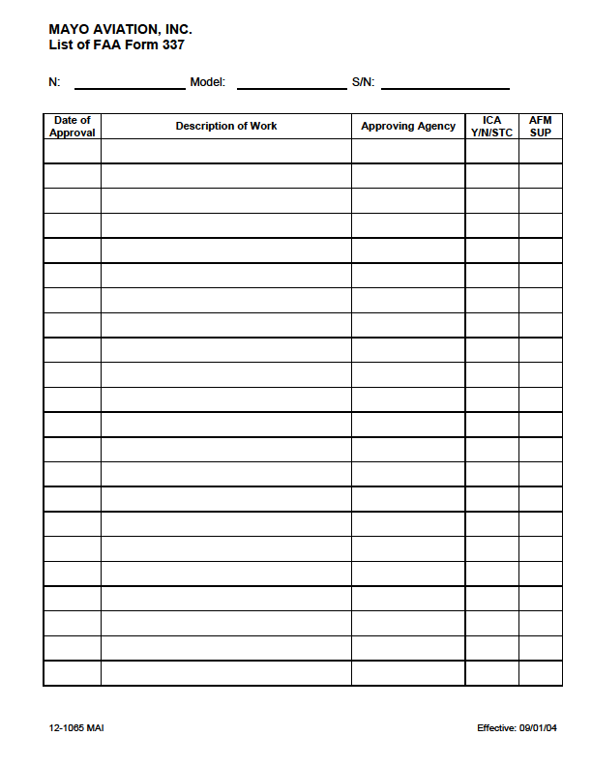

AFM SUP
Aircraft
Flight
Manual
Supplement
ICA
Instructions
For
Continued
Airworthiness

FAA
CRS
IA
Etc.

Anything that has been
Installed
Modified
Removed
Etc.

